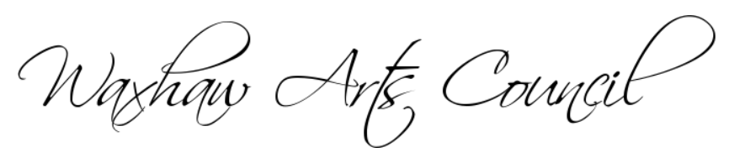
MEMBERSHIP APPLICATION
Please complete the application, include your check for $35 made out to “Waxhaw Arts Council” and bring to a WAC meeting or mail it to:
For convenience, we accept ZELLE
WAC Membership waxhawartscouncil@gmail.com
Attn: Rick Johnson
3240 Queensland Court
Fort Mill, SC 29707

PLEASE PRINT

NEW MEMBER__________ RENEWAL___________ DATE:________________________

NAME:__________________________________________________________________________________

MAILING ADDRESS:________________________________________________________________________

CITY, STATE, ZIP:__________________________________________________________________________

TEL:________________________________________

EMAIL:__________________________________________________________________________________

WEBSITE:________________________________________________________________________________

ART MEDIUM(S):__________________________________________________________________________

BIRTHDAY (Month & Day only):_______________NAME OF SPOUSE:________________________________

Your special talents, expertise or abilities that may be beneficial to WAC:__________________________________
_______________________________________________________________________________________________
COMMITTEES: Circle at least one committee you would be interested in Chairing or Assisting

EXHIBITS:
Founders Hall
Spirit Square
McDowell
UNCC
Novant
KALEIDOSCOPE (Work with Town of Waxhaw)
CONNECT WITH ART
PROGRAMS (Presentations, Demos, Workshops)
MINIMASTERS
SOCIAL MEDIA WEBSITE/PUBLICITY/ADVERTISING
VOLUNTEER COORDINATOR
COMMUNITY OUTREACH
STORAGE/SUPPLIES

*The Waxhaw Arts Council (WAC ) is a 501(c) (3), Non-Profit Corporation
*Meetings are scheduled for first Tuesday of the month (no July meeting)
*Website: www.waxhawartscouncil.org FB: Waxhaw Arts Group Page
*WAC Communication(s) to Members is sent via email

For Membership Use:
Check Number___________________________ Date_________________________ Amount_________________

